For Sale : Dawes Ultra Galaxy Touring Bike
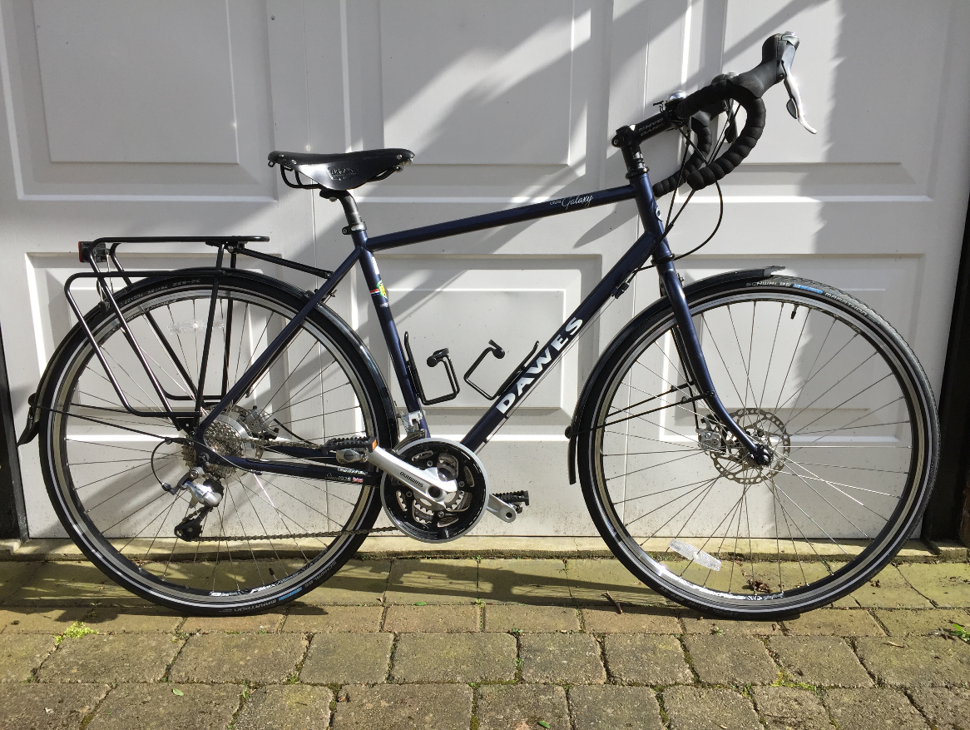
New Condition. Hardly Ridden (120 miles). Selling due to mobility problems following accident (not cycling).
2014 model : Frame 53cm

- Frame : Reynolds 853 double butted chromoly
- Colour : Matt French Navy Blue
- Fork : Triple butted chromoly
- Cranks : Shimano FC-T551, 48/36/26T,175mm crank
- Pedals: Shimano PD-505 Clipless
- Shifters: Shimano Tiagra 30 speed STI
- Cassette: Shimano Tiagra 12-30T 10 speed
- Hubs: Shimano T675 QR
- Rims: Alex XT19 double wall
- Tyres: Schwalbe 700x32C Marathon
- Brakes: Shimano BR-R515 mechanical disc
- Handlebar: Oversized short drop, short reach
- Stem: Alloy Ahead
- Saddle: Brooks B17 leather
- Seatpost: Micro adjust
- Extras: SKS full length mudguards, Tubus Logo alloy carrier
£775 ono
For further details please contact Martin Atkinson
Tel : 07742 050217 Email : Martin.N.Atkinson@BTopenworld.com

